

Tyneside Surgical Services Limited

Quality Account 2025 -2026



Quality Account
- What is the quality account? ---------------------------------------------- 3
- Regulatory statement ---------------------------------------------- 4
- Managing Director statement ---------------------------------------------- 5-6
- Accountability statement ---------------------------------------------- 6
- Mission ---------------------------------------------- 7
- Vision ---------------------------------------------- 7
- Values ---------------------------------------------- 7
- Qualities improvement priorities ---------------------------------------------- 8
- Quality Priorities 26-27 ---------------------------------------------- 9-10
- Quality Priorities 25-26 ---------------------------------------------- 11-13
- Statement of assurance ---------------------------------------------- 14
- Safety ---------------------------------------------- 14
12.1: Duty of candour ---------------------------------------------- 14
12.2: Emergency re-admission ---------------------------------------------- 15
12.3: Safeguarding ---------------------------------------------- 16 12.4: VTE ---------------------------------------------- 16
12.5: Safety incidents ---------------------------------------------- 17-18
- Infection Control ---------------------------------------------- 18
- Clinical Effectiveness ---------------------------------------------- 18
14.1: National Audit ---------------------------------------------- 18
14.2:Local Audit ---------------------------------------------- 18
- Statement of assurance from CQC ---------------------------------------------- 19
- Information Governance Assessment --------------------------------------------- 19
- Responsiveness to Patients need ---------------------------------------------- 20
- Summary ---------------------------------------------- 21

1. What is a quality account?

Quality Accounts were introduced under the Health Act (2009) to strengthen healthcare providers’ board level accountability for quality and place the reporting of this on an equal footing with financial reporting. Quality Accounts are both retrospective and forward-looking. The legal duty to publish an annual Quality Account applies to all providers of NHS- funded healthcare services.
This is our 2025-2026 report about the quality of services we provide and affords Tyneside Surgical Services (TSS) the opportunity to publish our quality priorities, identify room for improvement and celebrate what we have achieved.

How do we define and measure quality?

Caring
Responsive
Well Led

Patient Safety
Incidents
Infection Rates

Clinical Effectiveness
Readmission rates
Timeliness of care

Patient Experience
Patient Experience
Complaints and Compliments
Waiting times

2. Regulatory statements – statement on quality
Tyneside Surgical Services, an independent provider of NHS care, aspires to deliver first class services and clinical outcomes for our patients. Established in 2007, we introduced a new model of care that was unique to the North-East of England. In 2021, we successfully developed a brand-new day-case facility which launched in January 2022. As a result of the continuing pressures and challenges of the pandemic we recognised we needed to be dynamic in our approach ensuring that patients are at the forefront of any decision-making process.
We have offered consultant clinical services in eight elective specialties by named consultants via the national NHS e-Referral Service. We have continued to offer safe and effective services on behalf of NHS Integrated Care Boards (ICB’s). Such groups commission a range of services for patients in their local area. The lead commissioners for TSS is the North East and North Cumbria Integrated Care Board and they carefully monitor the quality and efficiency of the services we provide.
For the convenience of our patients, we have a wide range of outpatient specialty clinics at our own site, and primary care locations, day time, evening and weekends.
The site locations are at Independent House in Gateshead, Blaydon Primary Care Centre, Houghton Primary Care Centre, Washington Primary Care Centre, Pallion Family Practice, Sunderland and Broadway Medical Centre, Sunderland.
We engage consultant level staff both surgeons and anaesthetists who hold NHS substantive posts. In 2025 to 2026 we saw 4474 new patients and 4355 follow up patients in an outpatient capacity. Our consultant specialists performed 3331 procedures in this time.
We take pride in our consultant led service that offers excellent continuity of care. Our friends and family tests results showed that from April 2025 to March 31st, 2026, 99.4% of day-case patients would recommend our services, 99.8% of Endoscopy patients and 98.4% of patients visiting outpatients. We believe this is indicative of the outstanding care that we provide.

3. Statement on Quality from the Managing Director
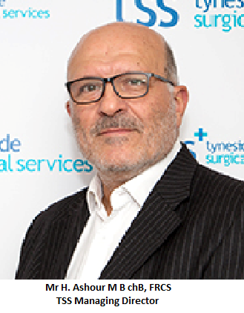
On behalf of Tyneside Surgical Services, I am pleased to present our 2025-2026 Quality Account. This report demonstrates the quality of services we have provided over the last year from April 25 to March 26.
This process provides us with an opportunity to review our achievements, look closely at our services and outcomes and plan accordingly with the team for the coming year.
As an organisation we remain committed to maintaining a strong and well governed partnership across the health economy. We recognised the pressures faced by the NHS, particularly in relation to diagnostic and elective services and therefore we successfully developed our own facility (Independent House) which opened in January 2022. This comprises of a day-case unit, an endoscopy/minor ops suite with access to an open MRI scanner, ultrasound scanning facilities and outpatient clinic consultation rooms. Developing this new unit has allowed us to assist a number of local Foundation Trusts with their waiting lists as well as remaining committed to successfully treating our own patients.

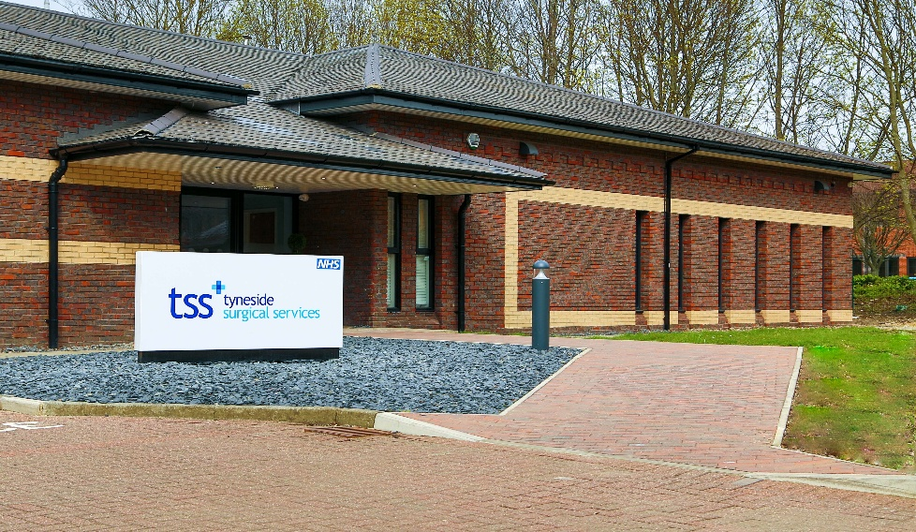

The CQC (Care Quality Commission) as the health and social care regulator both for the NHS and for independent providers undertook a full inspection of our services in June 2022 and we are pleased to report that our services were rated as ‘good’ with some elements of outstanding practice.
We anticipate that our quality account will provide confidence that TSS achievements are real in terms of clinical excellence, effectiveness, patient safety and clinical outcomes.
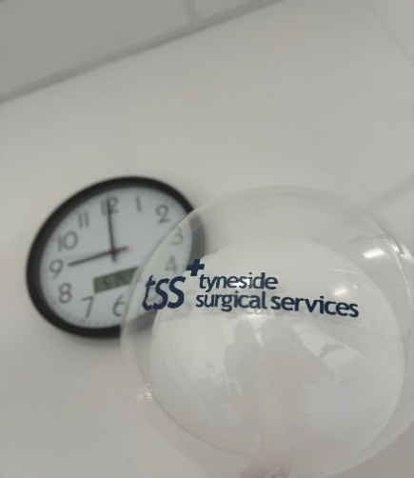

4. Accountability statement
Directors of organisations providing NHS services have an obligation under the 2009 Health Act, NHS (quality accounts) regulations 2010 as amended 2011 to prepare a quality account for each financial year. This report has been prepared based on the guidance provided and in line with the named requirements. It has therefore been written in good faith and the information accurate to the best of my knowledge and as requested by the said regulations in the governing communications.
Mr H Ashour, Managing Director

Mr Mark Mercer- Jones, Medical Director.
Mr Vish Bhattacharya, Clinical Governance Lead.
Mrs Laura Dalal, Director of Clinical Services.
Mr Steve Atkinson, Commercial Director.
Mr David Stoker, Director of Operations.

5. Mission
Tyneside Surgical Services purpose is to provide exceptional quality in the health care services we provide and in a manner that responds to the needs of our patients.

6. Vision
We aim to be the region's preferred independent provider, setting the standard for equality and choice in service provision.

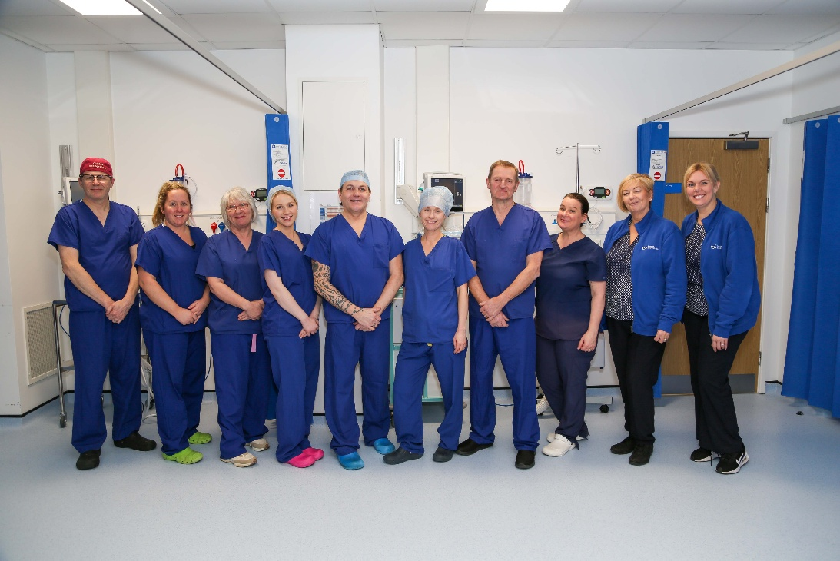

7. Values
- Respect the values and beliefs of all our patients
- Monitor the standards for care that we have set
- Manage health care delivery within the resources available
- Accept accountability for poor outcomes or poor patient feedback
- Continually strive to improve patient care and the quality of our services

8. Quality improvement priorities
Maintain JAG Accreditation for our endoscopy unit at Independent House
To continue to support Local Foundation Trusts with service pressures

Work in partnership with ICB to extend waiting times to meet the average RTT 15 weeks as set by the ICB.

The identification and development of our new quality objectives took into account the performance in clinical services, audit results and clinician feedback. Wider agreement on our priorities were achieved through senior manager and clinical governance meetings. Achievements and outcomes will be reported in next year’s Quality Account.
We shall continually monitor progress and achievement through our established internal reporting programmes and continue to share results with our commissioners as part of our joint quality review meetings

9. Tyneside Surgical Services 2026 – 2027 Priorities
Quality Priority | Priority detail | Measure
- Maintain JAG Accreditation | - Effectively managing the Endoscopy waiting lists as per National Guidance.  - Senior Management Team committed to timely intervention where patient access targets are at risk.  - Senior Management are valuable partners as an Independent Sector Provider to offer endoscopy services across the wider region.  - Ensure all staff are competent in their roles.  - Monitor patient experience  - Conduct audits in accordance with JAG accreditation quality standards/requirements.  - Ensuring the quality and safety of all endoscopy equipment.  - Senior Managers are compliant with all Health & Safety Legislation to ensure Endoscopy is a safe environment for patients, visitors & staff. | - Weekly monitoring of the Endoscopy waiting lists to prevents any breaches occurring.  - Conduct patient satisfaction surveys.  - Conduct annual review of staff competence through the appraisal systems.  - Conduct quarterly audits using the National Endoscopy Database (NED), Endoscopy IT systems and patient pathways.  - Maintain service contracts with the relevant clients in relation to the servicing and the maintenance of the Endoscopy Equipment (Wassenburg & Pentax).  - Actively participate in the North East and North Cumbria Endoscopy Network meetings to effectively manage demand and capacity for endoscopy services across the wider region.  - Complete all relevant Health & Safety Risk Assessments.
- To continue to support local Foundation Trusts with Service Pressures | - Service Level Agreements (SLA) in place for three Local Foundation Trusts for a variety of specialities and activity. | - Bi-weekly meetings to ensure effective, timely pathway for patients.  - Sharing patient trackers and weekly numbers of procedures and consultations undertaken.  - Number of procedures to perform agreed in SLA-stringent planning in place to ensure planned activity and access times are achieved.
- Work in partnership with the ICB to treat patient in a timely manner alongside recognised financial constraints.  - 70% 18 week RTT by March 2027, returning to 92% by March 2028. | - Ensuring accurate and timely data management information is available throughout the year.  - Ensure capacity and demand modelling is in place.  - Senior management team committed to timely intervention where patient access targets are at risk. | Waiting times, include no over 52 week waits and achieve and national targets for 18 week access fully achieved.  Data submissions all made on time with local and national requirements met and constant information sharing with local commissioners.

10. Tyneside Surgical Services 2025– 2026 priorities with results
Quality Priority (1) Achieve JAG Accreditation
Priority Detail | Measure
- Effectively managing the Endoscopy waiting lists as per National Guidance.  - Senior team committed to timely intervention where patient access targets are at risk.  - Senior Management are valuable partners as an Independent Sector Provider to offer endoscopy services across the wider region.  - Ensure all staff are competent in their roles  - Monitor patient experience.  - Conduct audits in accordance with Jag accreditation quality standards/ requirements.  - Ensuring the quality and safety of all endoscopy equipment.  - Senior Managers are fully compliant with all Health & Safety Legislations to endure the Endoscopy Department is a safe environment for patients, visitors & staff. | - Weekly monitoring of the Endoscopy waiting to prevent breaches occurring  - Conduct patient satisfaction surveys. Conduct annual review of staff competence through the appraisal systems.  - Conduct quarterly audits using the National Endoscopy Database (NED), Endoscopy IT systems and patient pathways.  - Maintain service contracts with the relevant clients in relation to the servicing and the maintenance of the Endoscopy Equipment (Wassenburg & Pentax).  - Actively participate in the North Eat and North Cumbria Endoscopy Network meetings to effectively manage demand and capacity for endoscopy service across the wider region.  - Complete all relevant Health & Safety Risk Assessments

Results
We are delighted to report that following an inspection in March 2026, Tyneside Surgical Services were awarded their first JAG Accreditation. The final report outlines a number of excellent achievements that tss were congratulated for;
- Excellent nursing leadership, always looking for innovative ways of working to improve the service with a clear passion for endoscopy and providing a 5-star service.
- Contributing to Corporate Social Responsibility through Local fundraising and sponsorship.
- Tyneside Surgical Services have a committed and visible leadership team with both clinical and operational leaders working in partnership to deliver a responsive service to patients.
- A robust governance process, including endoscopists’ performance (KPIs) review and 30day mortality and readmission process.
- A robust MDT referral process for newly diagnosed and suspected upper and lower GI cancers.
- Commended as an Independent Provider offering the provision of Advice and Guidance through the NHS England e-Referral system which was praised as innovative.
- Providing a patient centred booking system with flexibility in time and day of attendance of a clinical service that operates seven days per week.
- The service has maintained excellent Gastroenterology and Endoscopy wait times across both 18 Week Referral to treatment (RTT) and 6 Week Diagnostic (DM01)

Quality Priority (2) To continue to support Local Foundation Trusts with Service Pressure
Priority Detail | Measure
- Service Level Agreements (SLA) in place for a number of Local Foundation Trusts for a variety of specialties and activity. | - Sharing patient trackers and weekly numbers of procedures and consultations undertaken.  - Number of procedures to perform agreed in SLA-stringent planning in place to ensure planned activity and access times are achieved.

Results
We are pleased to report that 637 patients were treated to support Local Foundation Trusts with their waiting time pressures. We are honoured to be able to help these patients with their pathway of care, most of which had been waiting a considerable amount of time for their treatment, including cancer care.

Quality Priority (3) >92% of patients will achieve an 18 week pathway
Priority Detail | Measure
- Ensuring accurate and timely data management information is available throughout the year.  - Ensure capacity and demand modelling is in place.  - Senior management team committed to timely intervention where patient access targets are at risk. | - Waiting times, include no over 52 week waits and achieve and national targets for 18 week access fully achieved.  - Data submissions all made on time with local and national requirements met and constant information sharing with local commissioners.

Results
The National target as set by the NHS recovery trajectory states that 65% of patients should receive treatment within 18 weeks of referral by March 2026. Tyneside Surgical Services achieved 80% which is above and beyond this figure. We were forecast to achieve our quality priority of 92% but during the last financial year the ICB stipulated that we had to push out a minimum average of 12week RTT which has increased from our previous RTT of 9 weeks. This has been further increased to 15 weeks by the ICB so we will aim to make patients wait this length of time moving forwards unless they are a clinical priority.

11. Statements of Assurance
This section of the quality account provides mandatory information as determined by the regulations and serves to review our performance from 1 April 2025 to 31 March 2026.
Specialties that we provide are Orthopaedic Upper and Lower Limb, Spinal Surgery, Plastic Surgery, Urology, General Surgery, Vascular, Gynaecology, Pain Management, Upper Gastrointestinal, Lower Gastrointestinal/Colorectal and Gastroenterology. The table below shows TSS levels of elective activities.
Elective activity
 | 2024/2025 | 2025 / 2026
New | 4424 | 4474
Review | 3991 | 4355
Daycase | 2149 | 2412
Endoscopy | 1790 | 919

12. Safety
12.1 Duty of Candour
Duty of candour promotes a culture of openness and honesty regarding health outcomes that is pivotal to improving patient safety and the quality of healthcare systems and processes. It involves explaining and apologising for what has happened to patients who have been harmed as a result of their healthcare treatment. It ensures communication is open, honest and occurs as soon as possible following an incident. The duty ensures collaboration between individuals, teams, departments and hospitals. We believe we have timely and robust processes established for recognising when this duty has been breached and how we manage the patient communication and or family/carer relationship following a reportable patient safety incident.
The duty of candour policy is shared and available for all staff to ensure that the core responsibilities are understood and that the correct reporting processes are followed. There has been one duty of candour incident reported in the last financial year.
12.2 Emergency readmissions
This indicator looks at the number of patients who have been readmitted within 30 days of surgery aged 18 or over. Reasons for readmission can include infection, pain or other complications arising from their surgery. We collate this information as part of a set of key performance indicators. This information is shared and discussed at both the Clinical Governance and the Medical Advisory Committees. These are admissions to external hospitals as we only provide day case facilities and do not accept emergency admissions. In 2025 – 2026 there were 5 admissions within 30 days.

 | Q1 – 2025 | Q2 - 2025 | Q3 – 2025 | Q4 - 2026 | % of Total Admissions
2025- 2026 Re admission date within 30 days | 1 | 0 | 2 | 2 | 0.1%

As a day-case led unit, stringent screening during a pre assessment process is paramount. There are rare occasions where patients require transfer to an acute NHS hospital for an unplanned overnight stay. Below are the number of patients that have required transfer over the last 12 months.

 | Q1 – 2025 | Q2 - 2025 | Q3 – 2025 | Q4 - 2026 | % of Total Admissions
2025- 2026 Unplanned transfer rate to NHS hospital over overnight stay | 0 | 1 | 0 | 0 | 0.02%

12.3: Safeguarding
The Department of Health requires all healthcare providers to safeguard all those using their services from abuse. The Care Quality Commission (CQC) outcome statement similarly states that: ‘People who use services should be protected from abuse or the risk of abuse, and their human rights respected and upheld’.
To ensure that we fulfil this guidance, all our administration staff complete annual mandatory Level 1 safeguarding training via online courses (eLearning). All patient- facing staff also complete Level 2 designed to protect both children and adults. In addition, all clinical staff complete to Level 2.
The safeguarding policy is shared and available for all staff. There is openness and collaboration in the management and reporting of safeguarding issues.
We meet the requirement to obtain or conduct Disclosure and Barring Service (DBS) checks on the required staff. This is part of our recruitment and practice privilege process.

12.4: Risk assessment of venous thromboembolism (VTE)
This is for patients admitted to hospital who undergo operations and may have a risk of developing a potentially harmful blood clot or venous thromboembolism (VTE) most commonly in the deep veins of the leg.
100% of surgical admissions risk assessed for VTE 2025-2026.

APR | MAY | JUN | JUL | AUG | SEP | OCT | NOV | DEC | JAN | FEB | MAR
100% | 100% | 100% | 100% | 100% | 100% | 100% | 100% | 100% | 100% | 100% | 100%

12.5 Patient safety incidents
Tyneside Surgical Services has an established set of criteria to measure the
quality of care it provides to its users. We refer to them as Key Performance Indicators (KPIs). The table below show our results for the year 2025-2026.

KPI | Q1 - 2025 | Q2 - 2025 | Q3 - 2025 | Q4 – 2026
Deaths in service | 0 | 0 | 0 | 0
Unplanned re-admissions | 1 | 0 | 2 | 2
Unplanned returns to IH theatre | 0 | 0 | 1 | 0
Unplanned returns to other NHS theatres | 1 | 0 | 1 | 2
Transfers to other hospitals | 0 | 1 | 0 | 0
Post-operative infection rates | 1 | 0 | 2 | 0
Serious Incidents | 0 | 0 | 0 | 0
Never events | 0 | 0 | 1 | 0
Duty of candour | 0 | 0 | 1 | 0
Formal complaints | 2 | 2 | 0 | 1
Incident forms completed | 3 | 1 | 3 | 1
KPI | 2022 -2023 | 2023 -2024 | 2024-2025 | 2025-2026
Deaths in service | 0 | 0 | 0 | 0
Unplanned re-admissions | 7 | 3 | 8 | 5
Unplanned returns to IH theatre | 0 | 2 | 0 | 1
Unplanned returns to other NHS theatres | 1 | 3 | 3 | 4
Transfers to other hospitals | 0 | 3 | 2 | 1
Post-operative infection rates | 1 | 8 | 7 | 3
Serious Incidents | 0 | 0 | 0 | 0
Never events | 0 | 0 | 0 | 1
Duty of candour | 0 | 0 | 0 | 0
Formal complaints | 2 | 2 | 2 | 5
Datix completed/Incident Form Completed | 7 | 4 | 5 | 8

We promote open reporting of all incidents and accidents, including no harm/prevented harm and near miss incidents. It is a mandatory requirement for all providers of healthcare services to have a procedure for reporting incidents.
TSS utilises its own paper-based incident reporting system. The entries are reviewed monthly at the clinical governance meeting. Any serious incidents are escalated immediately to the team, CQC and the ICB.
13. Infection control
Infection control remains a key element of any organisations audit programme. We monitor infection rates through organisational key performance indicators (KPI’s). TSS continues to screen patients pre operatively for Methicillin-resistant Staphylococcus aureus (MRSA), for those whom are found positive, they are fully treated and re screened prior to proceeding with their surgical procedure. TSS has had no post operative reported cases of MRSA or Clostridium Difficile in 2025 -2026.
14. Clinical Effectiveness
14.1: National audit
As a small provider we had previously participated in national audits relevant to the services we provided. These services (Total Hip Replacements and Total Knee Replacements) are no longer provided by TSS due to moving towards providing a purely day-case pathway.
14.2: Local audit

Going forwards the Clinical Governance committee and the Medical Advisory Committee have agreed the following programme as part of our clinical effectiveness.
- Notes Audit
- WHO Checklist Audit
- Endoscopy Audits in accordance with JAG compliance
- Surgical VTE Risk Assessment Audit
- Infection Prevention & Control

15. Statement of assurance from the CQC
TSS is required as a provider to register with the CQC under section 10 of the Health and Social Care Act 2010. We were last inspected in June 2022. We were rated overall as good and there are no conditions attached to the registration. We are registered for the following regulated activities:
- Treatment for disease, disorder or injury
- Diagnostic or screening procedures
- Surgical procedures

We have not at any time been subject to an investigation or special review by the CQC.

16. Information Governance Assessment
We take our responsibilities very seriously to protect and maintain the confidentiality of patient information. The Caldicott Guardian, who is responsible for the security of patient information, leads this work and is committed to the highest standards. We have had no reportable incidents to the information Commissioners Office in 2025/26.
The Data Protection Security Toolkit was successfully completed in June 2025. We continue to be compliant with the data requirements of the new general data protection regulation (GDPR). The primary aim of the GDPR is to protect the public’s personal data. The toolkit is due for renewal in June 2026.

17: Responding to Patient needs
Friends and Family patient satisfaction survey:
Each new patient seen in an outpatient capacity is offered the opportunity of completing a patient satisfaction card. Transcribed are the nationally recognised questions and those relevant to our services. We identify which consultant outpatient clinics the cards have been returned from.
The results are shared at internal meetings for both positive and negative comments. We are cognisant that this is an important measurement of patient feedback and a representative reflection of our patient’s experience.
Alongside the launch of the new Independent House Facility, we introduced the patient feedback cards in January 2022. Since that time, feedback has been outstanding and is shared amongst the team.
Since September 2023 we introduced a patient feedback card specifically for endoscopy. Tyneside surgical services therefore divides their patient feedback cards to three main areas. Outpatients, Surgical procedures and Endoscopy procedures (inclusive of Cystoscopy procedures).
We are proud to share the following outstanding results for 2025-2026; 99.8% of patients would recommend our endoscopy services to their family and friends. 98.4% of patients would recommend our outpatient services to their friends and family. 99.4% of patients would recommend our surgical services to their friends and family.

Sample Size | Percentage of patients that are either Extremely Likely or Likely to recommend our service to their friends and family
Endoscopy 964 | 99.8%
Daycase 657 | 99.4%
Outpatients 1399 | 98.4%

18. Summary
We continue to strive to deliver services with a caring, compassionate and holistic approach. Pivotal to this is ensuring that our staff are equipped with the skills, knowledge and attitude to respond to the needs of our patients. TSS clinicians are inclusive decision makers and a whole team approach has been adopted to enhance patient safety and the quality-of-service delivery.
We are excited to see what we achieve in the forthcoming year and are honoured to continue to assist Local Foundation Trusts with waiting list pressures.



